Exercise 1: Create an Azure App Service resource by using a Docker container image

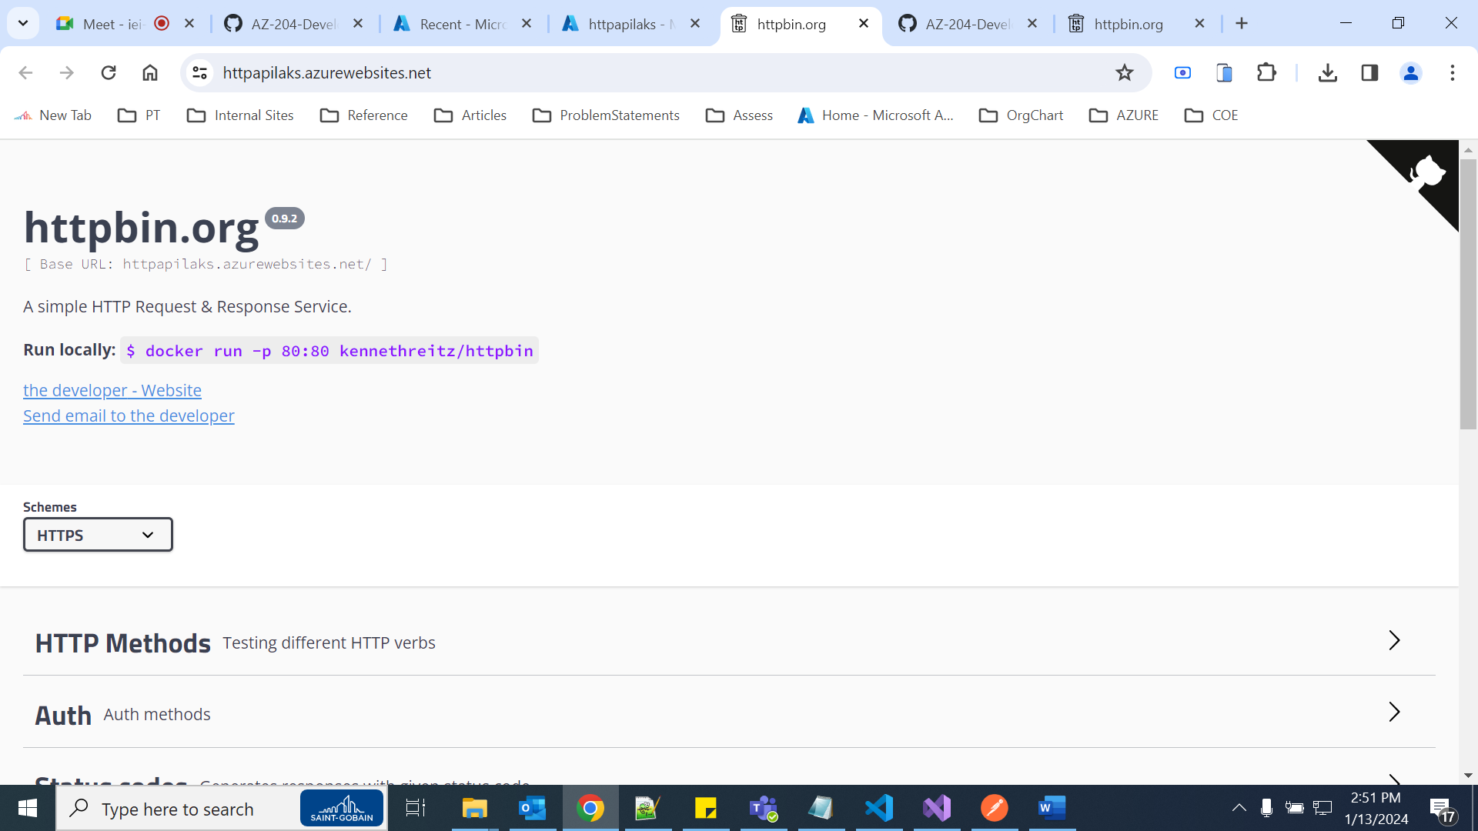

Exercise 2: Build an API proxy tier by using Azure API Management

